**Ecology & Society Feature Volume for OceanCanada**

**Contents for the Feature:**

1. Introduction (Rashid and David)
2. The international law and policy seascape for managing shifting species and ecosystems (Phillip and Cecilia)
3. Are transboundary fisheries management arrangements in the North Pacific and North Atlantic seaworthy in a changing ocean? (Olga and David)
4. Current state and future scenarios for transboundary fisheries management in changing oceans of Canada and the US: gauging the biological tides (Juliano, William & Rashid)
5. Game theoretic insights into the bilateral management of key transboundary fisheries of Canada and the United States under climate change (Rashid, Juliano & William)

**Key Dates:**

***Draft available for circulation to all by June 14*** (in advance of the IMBeR June 2019 meeting)

***Final revised article 19 July 2019***

*Any questions and submission of articles can be sent to Susan at seawindscs@eastlink.ca*

Word Count: We ask that you keep your total ***word count to 5,000*** (additional words will increase the charge for publishing your article)

Word counts are based on number of words in the abstract and main text only (not including the Literature Cited, tables, figures or appendices).

**Author Guidelines**

*Further details are available at https://www.ecologyandsociety.org/about/submissions.php#guidelines*

1. **Title, Abstract, Key words/phrases, and Acknowledgments**

* Title
  + The title should be entered with only the first word and proper nouns capitalized.  
    Example: "Basic science, applied science, and the radical middle ground"
  + Avoid abbreviations
* Abstracts
  + Abstracts should be less than 300 words.
  + They should not contain citations.
  + Avoid abbreviations - if used they must be first spelled out.
* Key words/phrases should be listed alphabetically and separated by a semicolon.
* Acknowledgements should be set as the first footnote using an asterisk “*”.

**2. Body of the manuscript** (from Introduction through to end of Literature Cited) 

* [Headings and subheadings](https://www.ecologyandsociety.org/about/submissions.php#headings)
* [Equations, Greek symbols, and statistics](https://www.ecologyandsociety.org/about/submissions.php#equations)
* [Text Boxes](https://www.ecologyandsociety.org/about/submissions.php#boxes)
* [Details of style](https://www.ecologyandsociety.org/about/submissions.php#style)
  + [Within text referencing](https://www.ecologyandsociety.org/about/intext)
  + [Spacing, fonts, and page numbering](https://www.ecologyandsociety.org/about/submissions.php#spacing)
  + [Underlining/italicization](https://www.ecologyandsociety.org/about/submissions.php#underlining)
  + [Capitalization](https://www.ecologyandsociety.org/about/submissions.php#capitalization)
  + [Footnotes](https://www.ecologyandsociety.org/about/submissions.php#footnotes)
  + [Units](https://www.ecologyandsociety.org/about/submissions.php#units)
  + [Statistics](https://www.ecologyandsociety.org/about/submissions.php#statistics)
  + [Web (HTML) links](https://www.ecologyandsociety.org/about/submissions.php#links)
* [Literature cited](https://www.ecologyandsociety.org/about/submissions.php#literaturecited)

***Headings and subheadings*** must appear on a line by themselves   
  
Main headings:

* Standard headings should be used preferentially (if apprpriate)
* INTRODUCTION, METHODS, RESULTS, DISCUSSION, CONCLUSION, LITERATURE CITED
* Other headings are permissible
* Use LITERATURE CITED (not Bibliography, References, nor anything else)
* centered on a line by themselves

Secondary headings

* left-justified on a line by themselves
* bolded
* lowercase except for initial letter of the first word
* e.g., **General characteristics of movement**

Tertiary headings

* left-justified on a line by themselves
* italicized
* lowercase except for initial letter of the first word
* e.g., *Field study and simulation model*

***Text Boxes***  
  
To set content apart in a Text Box, place <txt#> at the beginning and </txt#> at the end of the content (where # = 1, 2, 3... is the appropriate box number). Put into the body of the manuscript in the approximate desired location.   
  
***Details of Style***

*Spacing and Fonts*   
  
Single-space all material.  
Separate paragraphs with a blank line.  
Use a 12-point font (preferably Times Roman).   
Italicize scientific names and the symbols for all variables and constants.   
Symbols in illustrations should be italic to match the text.   
Italics should NOT be used for emphasis.  
Do not underline text.   
  
*Capitalization*  
  
For common names of birds use initial capital letters: Black-throated Green Warbler. For all nonavian taxa, use lower case for common names.   
  
*Units*   
  
Use the International System of Units (Systeme Internationale: SI) for measurements. Consult *Standard Practice for Use of the International System of Units* (ASTM Standard E-380-93) for guidance on unit conversions, style, and usage. When preparing text and figures, note in particular that,

1. SI requires the use of the terms mass or force rather than weight;
2. use the solidus (/); for two or more units in a denominator, use negative exponents; and
3. use a capital L as the symbol for liter.

*Statistics*   
  
Use leading zeroes with all numbers <1, including probability values (e.g., P < 0.001). For every significant F statistic reported, provide two df values (numerator and denominator). Whenever possible, indicate the year and version number of the statistical software used.   
  
*Web (HTML) links*   
  
Authors may include links to other Internet resources in their article [e.g., the Breeding Bird Survey (http://www.mbr-pwrc.usgs.gov/bbs/bbs.html)]. When inserting a reference to a webpage, please include the http:// portion of the address. 

* The *Council of Science Editors (CSE) Style Guide*, is recommended for details of style.
* Manuscripts are currently accepted in English only.
* Write with precision, clarity, and economy:   
  use the active voice and first person whenever appropriate.
* Use American spellings (e.g., behavior, not behaviour) except when quoting or in citations.

*Referencing/Footnotes* 

In general, use Harvard Referencing System.

Avoid footnotes in the body of the manuscript; Footnotes below tables are acceptable; instead of numbers, please use (in order): †, ‡, §, |, ¶, #, ††, ‡‡, §§, ||, ¶¶, ##.   
  
Use within text referencing

* include author plus year of publishing, (Smith 2000)
* separate two references with a comma, (Smith 2000, Green 2002)
* list oldest reference first, (Smith 2000, Green 2002, Brown 2012)
* if two authors give both names, if three authors use 'et al.', (Smith and Brown 2000, Smith et al. 2012)
* the same author in two different years- name the author only once (Smith 2000, 2012, Brown 2013)
* the same author in the same year, designate with italicized letters (Smith 2000*a*)
* direct quotes should include date followed by page number (Smith 2000:197)
* second hand references (Smith 2000, as cited in Brown 2005)  
  Note: Smith 2000 should not appear in Lit. Cited section.

Literature cited

* Each citation in the text must be included in the Literature Cited section.
* Every reference in the Literature Cited must be referred to in the text.
* The list should conform in sequencing and punctuation to that found in recent issues of *Ecology and Society*.

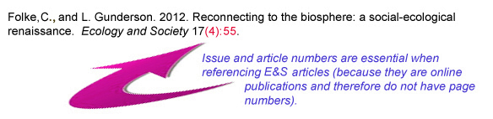  
Citing Ecology and Society:    
Example Journal Citation:

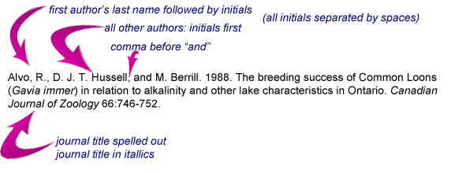

* All journal titles should be spelled out completely (i.e., do not abbreviate journal titles).
* In the titles of articles, the spellings of all words should agree with that used in the original publication.
* Provide the publisher's name and location when you cite symposia or conference proceedings; distinguish between the conference date and the publication date if both are given.
* Do not list abstracts or unpublished material in the Literature Cited. They may be listed in the text as personal observations (by an author of the present paper), personal communications (from others), or unpublished *x*, where *x* = data, manuscript, or report;
* Provide authors' names and initials for all unpublished data, manuscripts, and reports in the text of the paper.
* Links to online, freely available articles are permitted. Please use the following format:   
  [online] URL: http://CRAN.R-project.org/package=lme4
* Do not include links to password-protected websites or an author's website. Exceptions to this rule include links to Birds of North America species accounts and links to author's websites that post a software program that is not available by any other means and is integral to the paper.
* Insert spaces between author's initials.
* Last name appears first for first author; initial(s) first for subsequent authors.
* Books and conference proceedings must include publisher information: name, city, state or province (if pertinent), country.
* Conference proceedings must include the city, state/province, country, and year in which the conference was held. Conference dates are typically included, although not required. The editor(s) of the Proceedings should be included, if possible.
* Journal articles in press should include the volume number of the journal even if the page range is not known.

**3. Attachments (tables, figs, etc.)**   
  
All tables, figures, appendices, videos, computer simulations, and databases constitute attachments to the body of the manuscript. As such, they must be submitted as separate files.

Please see the [Equations](https://www.ecologyandsociety.org/about/submissions.php#equations) section below for information on how to format equations.

* [Tables](https://www.ecologyandsociety.org/about/submissions.php#tables)
* [Figures](https://www.ecologyandsociety.org/about/submissions.php#figures)
* [Appendices](https://www.ecologyandsociety.org/about/submissions.php#textapp)

**Tables (saved as .rtf files)**

* The table's caption is entered separately and should not appear in the table.
* Single space
* Row and column entries separated by cell divisions using the table function in word processing software.  
  (That is, tabs, spaces, or blank lines to separate information will not work.)
* No horizontal or vertical lines (borders) to separate cells
* No images within tables
* No color
* Use regular font in column and row headings (no bold or italics)
* Do not merge rows, merging across columns is okay
* No bulleted or numbered lists
* Asterisks are reserved to denote levels of significance, not for footnotes
* Superscripted numbers may be used to identify citations within a table
* The footnote symbols should be in the order: †, ‡, §, |, ¶ , #, and then doubled symbols. (See CSE Style Manual).
* Do not include information in tables that is not discussed in the text of the manuscript.

Example Tables:   
[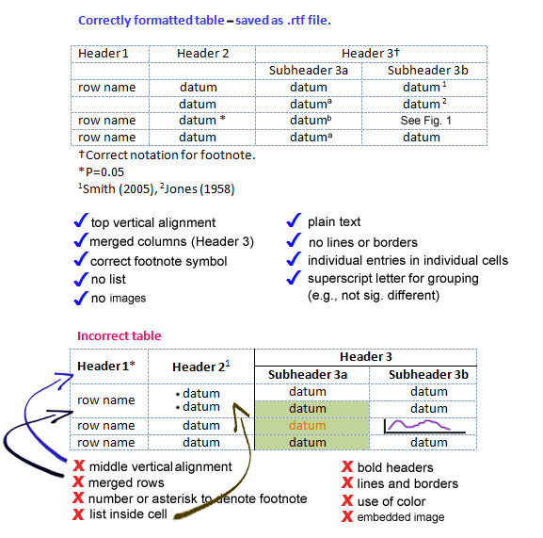](https://www.ecologyandsociety.org/about/submissions.php#tables) 

**Figures**

* Figures are added during Step 5 of the submission process.
* Figures must be clear and sharp.
* Use imaging software (Excel does not export graphs well).
* Figures must be in .GIF, .PNG, or .JPG formats.
  + For photos or images with gradients of color use JPG.
  + For images with flat colour use GIF or PNG8.
* up to 300 ppi and no wider than 2000 pixels (unless given explicit permission by the [managing editor](mailto:managing_editor@ecologyandsociety.org)).
* the image will be printed 7.5 cm wide (complex figures may be printed at 16cm) - text should be legible, clear, and sharp at that size. Print your figure at 7.5 cm; is it legible, clear, and sharp?
* We may ask you to supply high resolution, print-quality versions of your figures.
* Font must be large, legible, and sans serif; Arial font is best.
* Use a white background
* No title or caption information in the figure. That information is entered elsewhere.
* Initial upper case letters are preferred except where SI requires lower case letters for unit abbreviations (e.g., dbh, ln).
* No border around your figures
* Color figures are encouraged. Please verify they will print well in black-and-white (and that colour selection would be distinguishable to people who are red-green colour-blind).
* Use shaded, or hatched bars in preference to color or black ones.
* Use italic lettering for single-letter variables, constants, and scientific names in illustrations to make them consistent with the text.
* Use bar graphs in preference to pie charts

[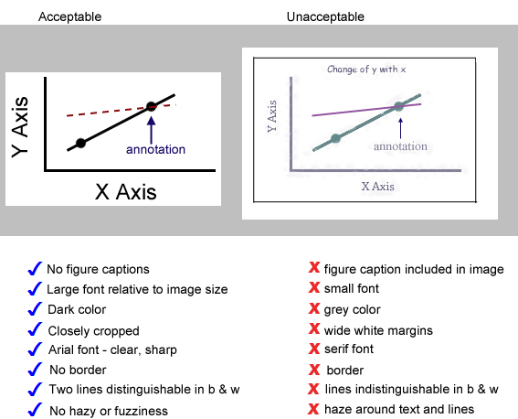](https://www.ecologyandsociety.org/about/submissions.php#figures)  
Example Figures:   
 

**Appendices**   
  
*Appendices are not copy edited nor formatted prior to publication so authors must ensure that their appendix is formatted correctly.*  
  
Appendices containing text, tables, and/or figures should be uploaded as PDF, formatted according the journal's style.   
  
The top margin of the appendix must be 4 cm.  
  
Include a heading and caption in your pdf, where the heading "**Appendix #.**" is left aligned, bold, and the caption (not bold) is Sentence Case.  
  
Table and figure numbers in appendices should be keyed to the letter identifying that appendix:   
Fig. A1.1, for Figure 1 in Appendix 1;   
Table A2.3 for Table 3 in Appendix 2.   
Equations should be numbered similarly: A2.3, for Equation 3 in Appendix 2, and so on.  
  
Tables are formatted with a double line above the heading, and single lines below the heading and below the last table row.  
  
Enter all title and caption information when asked during the submission process, and upload each appendix as a separate file.   
  
*Other appendices*   
  
All nontext appendices, such as databases, video, or sound files may be uploaded using an appropriate filetype for the file contents. Appendices should be labeled logically to indicate content (i.e. "Program#.filetype", "Sound#.filetype"). Captions should describe the attachment fully (by content, file format, usage, software required to run them, etc.) and are uploaded separately during the submission process. 